Exp no :01 Date :

Evidence Acquisition Using Access Data FTK Imager

Description

Forensic Toolkit or FTK is a computer forensics software product made by AccessData. This is a Windows based commercial product. For forensic investigations, the same development team has created a free version of the commercial product with fewer functionalities. This FTK Imager tool is capable of both acquiring and analyzing computer forensic evidence.
The evidence FTK Imager can acquire can be split into two main parts. They are:

- Acquiring volatile memory
- Acquiring non-volatile memory (Hard disk)

There are two possible ways this tool can be used in forensics image acquisitions:

- Using FTK Imager portable version in a USB pen drive or HDD and opening it directly from the evidence machine. This option is most frequently used in live data acquisition where the evidence PC/laptop is switched on.
- Installing FTK Imager on the investigator’s laptop.
In this case the source disk should be mounted into the investigator’s laptop via write blocker. The write blocker prevents data being modified in the evidence source disk while providing read-only access to the investigator’s laptop. This helps to maintain the integrity of the source disk.

Acquiring volatile memory using FTK Imager

The FTK Imager tool helps investigators to collect the complete volatile memory (RAM) of a computer. The following steps will show you how to do this.
Open FTK Imager and navigate to the volatile memory icon (capture memory).

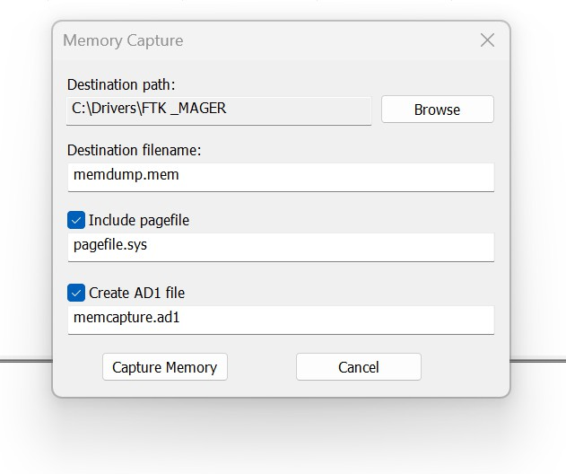

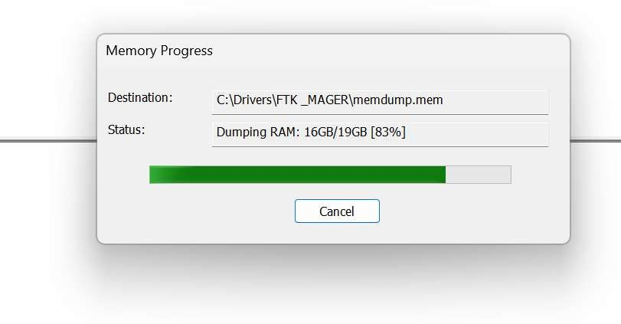

NOTE: This tool provides options to include pagefile and AD1 files when acquiring the volatile memory.
Pagefile: The pagefile (pagefile.sys) is used in Windows operating systems as volatile memory due to limitation of physical random-access memory (RAM). It is located under the “C” partition ready to use as volatile memory when the existing RAM capacity is exceeded. So this file can have quite a bit of valuable data when considering the volatile memory. Therefore, it is recommended to capture and collect this file in the acquisition.
AD1 file: AD1 is the FTK imager image file. The investigator has the option to create an AD1 file for later use.
Clicking the “capture memory” button will start acquiring the volatile memory.

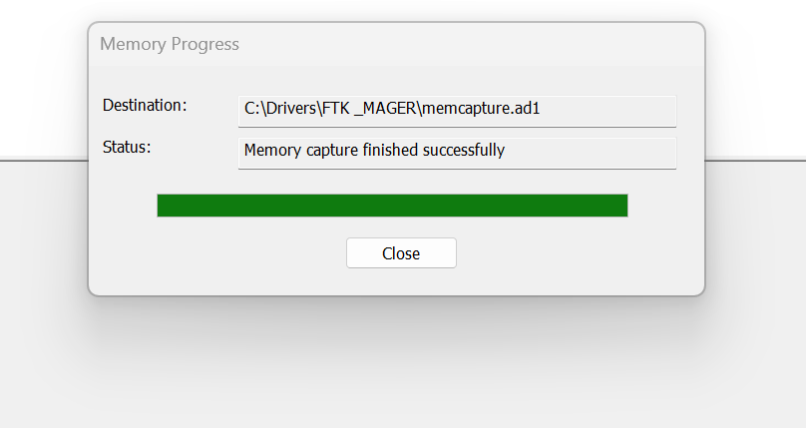

NOTE: Once the acquisition has completed, the destination folder will have the acquired memory with the file extension of “.mem”.
Acquiring non-volatile memory (Disk Image) using FTK Imager

As previously stated, this same tool can be used to collect a disk image as well. Open FTK Imager and navigate to “Create Disk Image”.

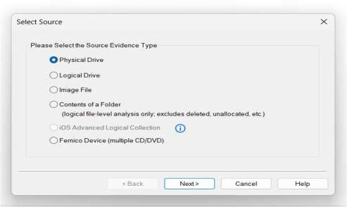
NOTE: FTK Imager is capable of acquiring physical drives (physical hard drives), logical drives (partitions), image files, contents of a folder, or CDs/DVDs. Investigators can connect external HDDs into the collection computer
via write blocker and use the “logical drive” option to select the mounted HDD as a partition.
Collecting Physical Drives

Select the “Physical Drive” option.

Select the drive you need to acquire and click “Finish”.

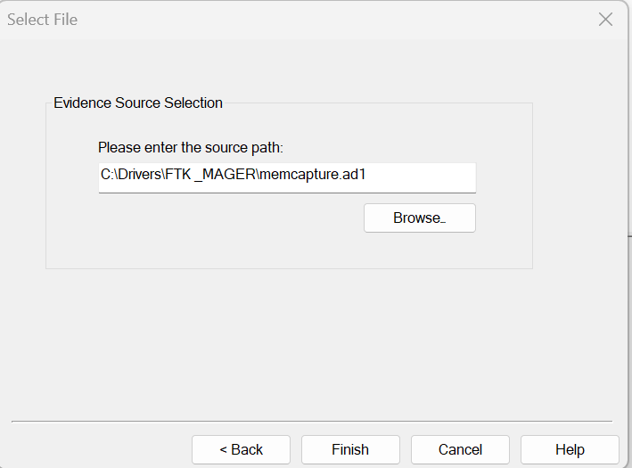

Raw (dd): This is the image format most commonly used by modern analysis tools. These raw file formatted images do not contain headers, metadata, or magic values. The raw format typically includes padding for any memory ranges that were intentionally skipped (i.e., device memory) or that could not be read by the acquisition tool, which helps maintain spatial integrity (relative offsets among data).
SMART: This file format is designed for Linux file systems. This format keeps the disk images as pure bitstreams with optional compression. The file consists of a standard 13-byte header followed by a series of sections. Each section includes its type string, a 64-bit offset to the next section, its 64-bit size, padding, and a CRC, in addition to actual data or comments, if applicable.
E01: this format is a proprietary format developed by Guidance Software’s EnCase. This format compresses the image file. An image with this format starts with case information in the header and footer, which contains an MD5 hash of the entire bit stream. This case information contains the date and time of acquisition, examiner’s name, special notes and an optional password.
AFF: Advance Forensic Format (AFF) was developed by Simson Garfinkel and Basis Technology. Its latest implementation is AFF4. The goal is to create a disk image format that does not lock the user into a proprietary format that may prevent them from being able to properly analyze it.
Now enter the case details.

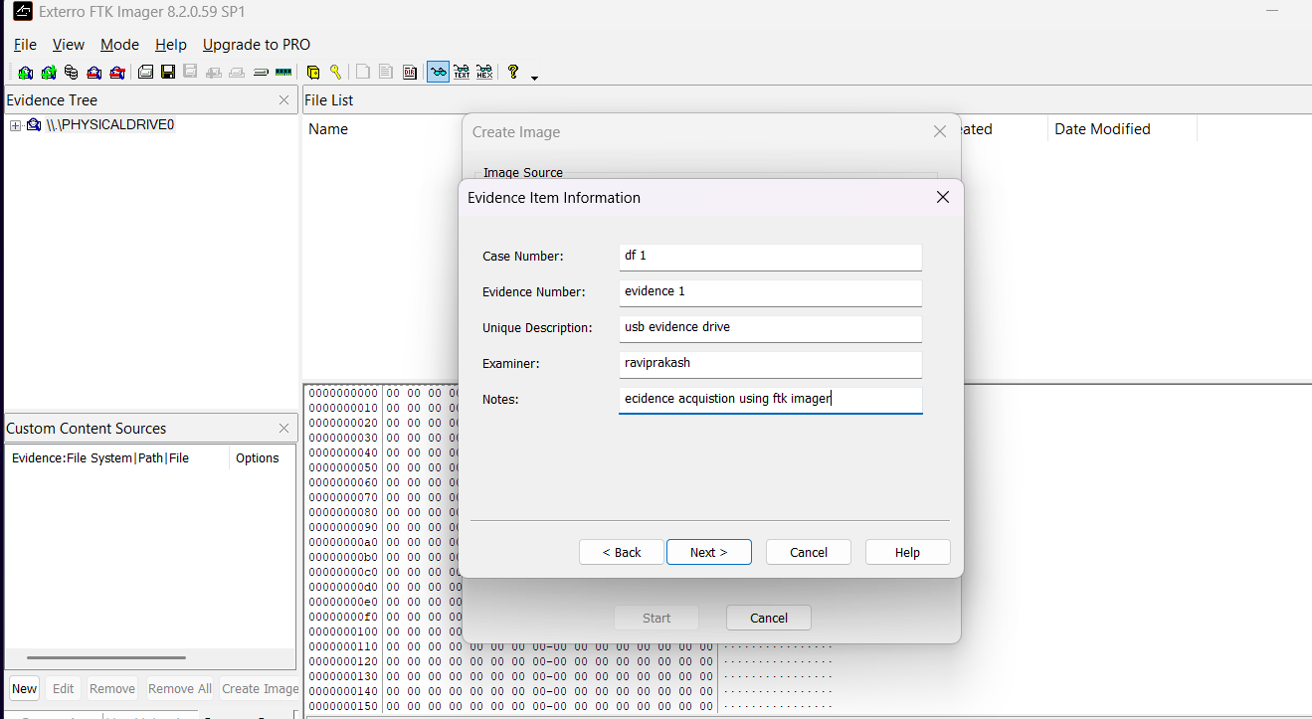

Add an image destination (where the image file will be saved), image file name and fragment size.

Image Fragment Size (MB): this option will separate the image file into multiple images and save
them in the same destination. If you need only one file instead of creating multiple fragmented images, you must set the image fragment size to “0”.
Select the “verify images after they are created” option. This will verify the hash values once the image has created. In order to ensure integrity, it is recommended to use this option. However, this will increase the time taken to acquire your evidence, especially if you’re dealing with a large disk image size.
Click “start” to start acquiring.

Once acquiring is complete, it will create a text file including all the information it has acquired.

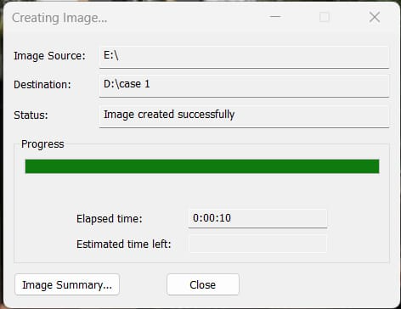

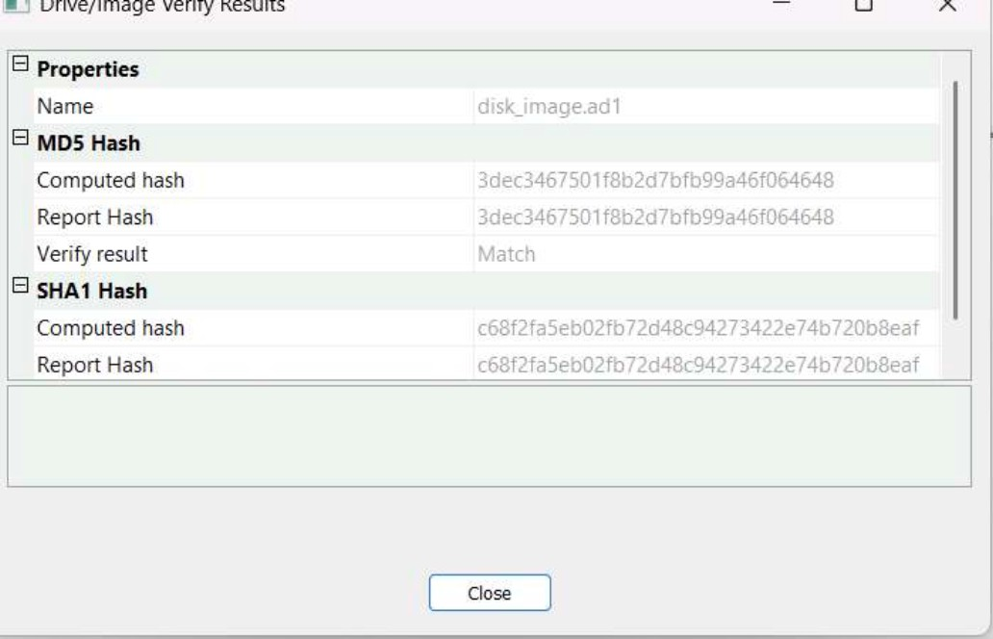

Hash values are matched.

Exp no :02 Date :
Recover deleted or damaged files from a storage device using
Test Disk

Description:
TestDisk step by step to recover a missing partition and repair a corrupted one.

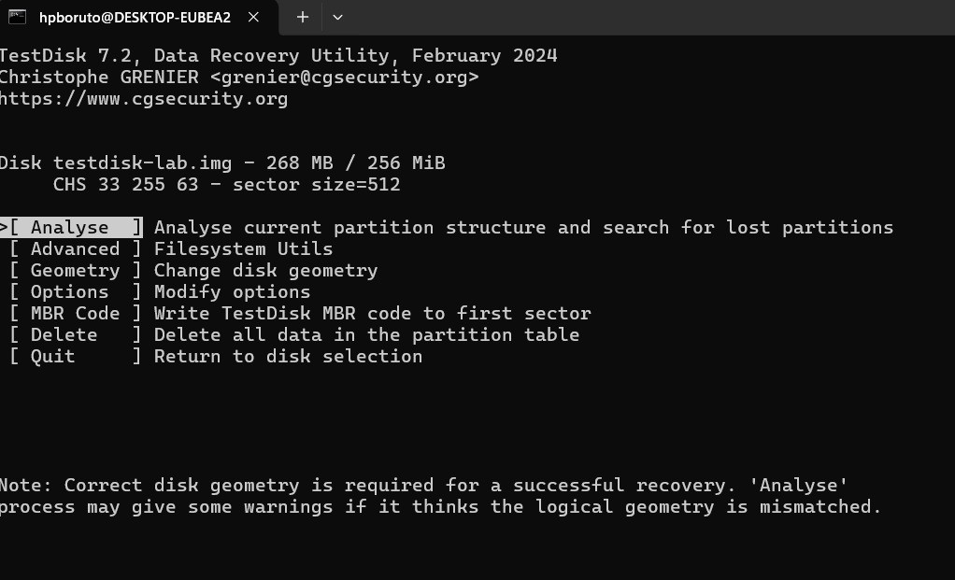
Log creation

- Choose Create to instruct Testdisk to create a log file containing technical information and messages, unless you have a reason to append data to the log or you execute TestDisk from read only media and must create the log elsewhere.
- Choose None if you do not want messages and details of the process to be written into a log file (useful if for example Testdisk was started from a read-only location).
- Press Enter to proceed.

Disk Selection
All hard drives should be detected and listed with the correct size by TestDisk:

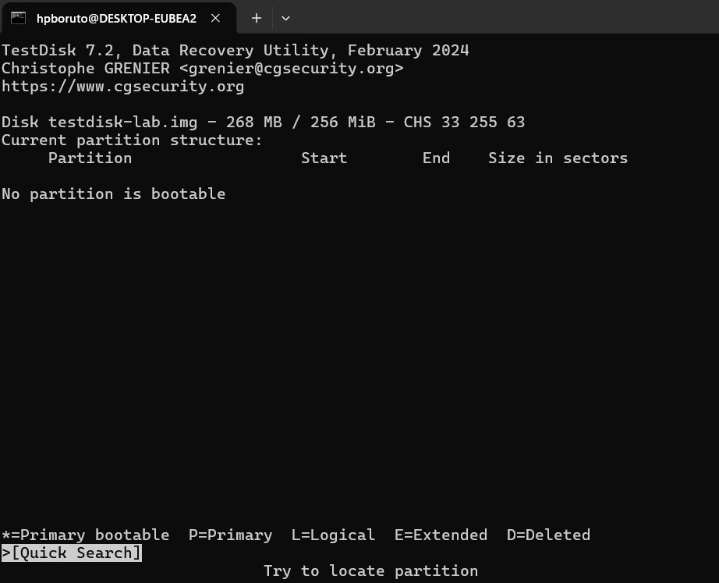

- Use up/down arrow keys to select your hard drive with the lost partition/s.
- Press Enter to Proceed.
If available, use raw device /dev/sda* for faster data transfer.

Partition table type selection
TestDisk displays the partition table types.

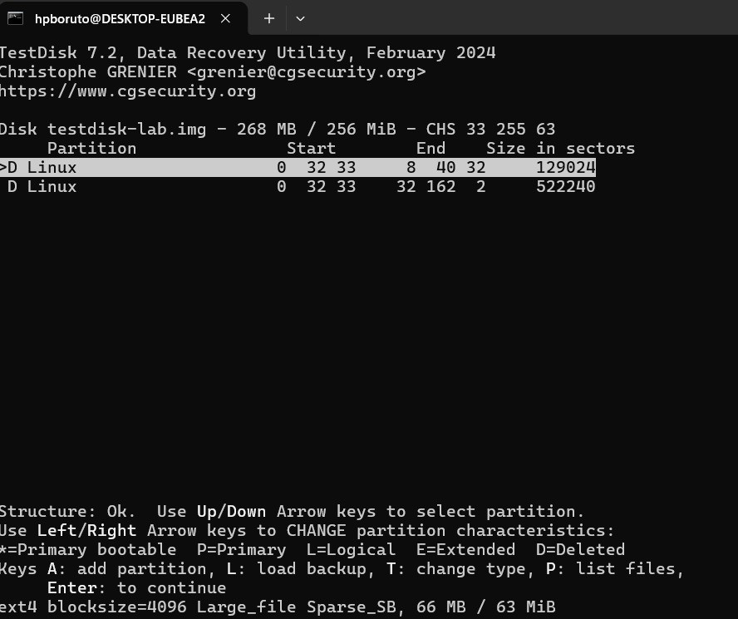

- Select the partition table type - usually the default value is the correct one as TestDisk auto-detects the partition table type.
- Press Enter to Proceed.

Current Partition Table Status
TestDisk displays the menus (also see TestDisk Menu Items).

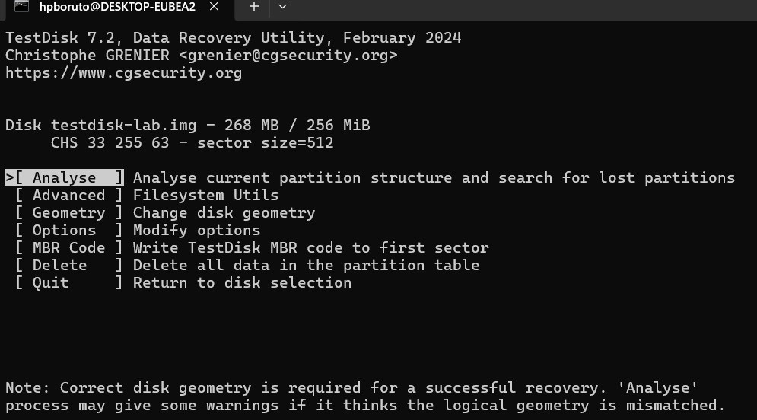

- Use the default menu "Analyse" to check your current partition structure and search for lost partitions.
- Confirm at Analyse with Enter to proceed.

Now, your current partition structure is listed. Examine your current partition structure for missing partitions and errors.

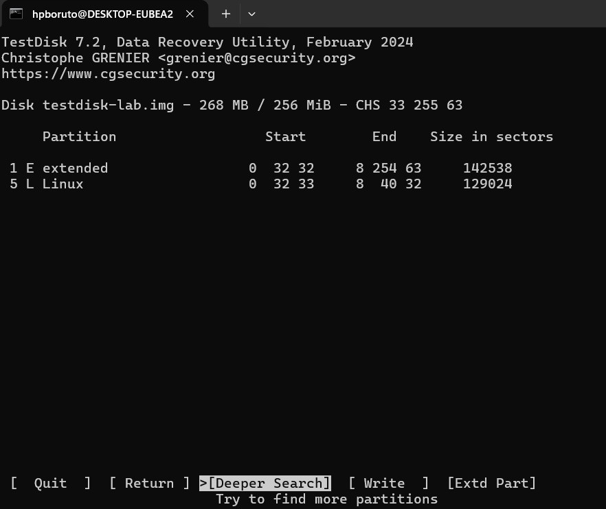

The first partition is listed twice which points to a corrupted partition or an invalid partition table entry.
Invalid NTFS boot points to a faulty NTFS boot sector, so it's a corrupted filesystem.
Only one logical partition (label Partition 2) is available in the extended partition. One logical partition is missing.
- Confirm at Quick Search to proceed.

Quick Search for Partitions
During the Quick Search, TestDisk has found two partitions including the missing logical partition labeled Partition 3.
- Highlight this partition and press p to list your files (to go back to the previous display, press q to Quit, Files listed in red are deleted entries).
All directories and data are correctly listed.
- Press Enter to proceed.

Save the Partition table or search for more partitions

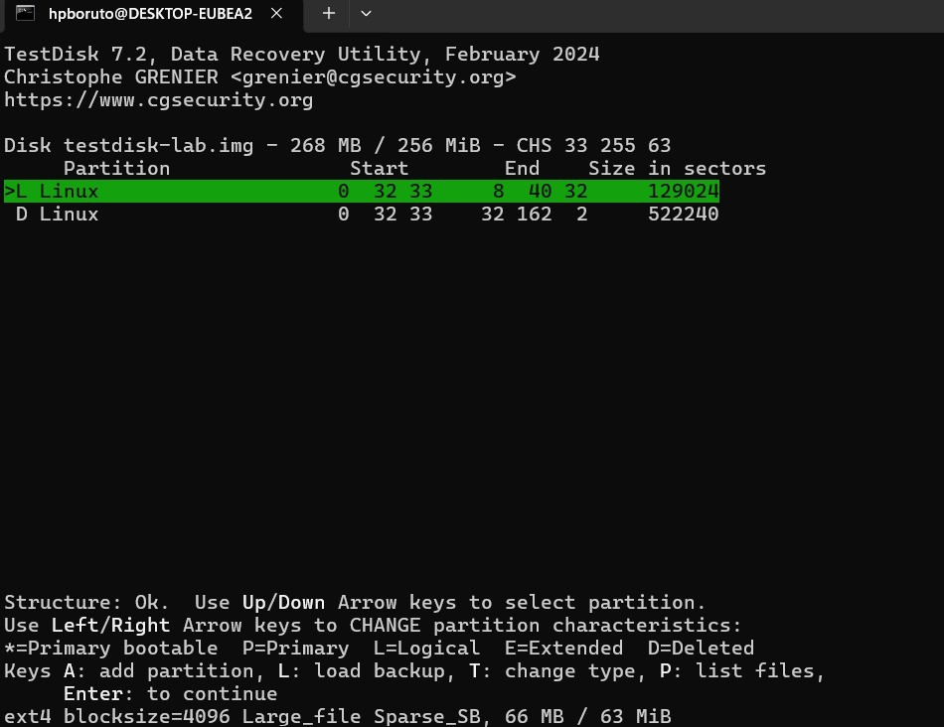

- When all partitions are available and data correctly listed, you should go to the menu Write to save the partition structure. The menu Extd Part gives you the
opportunity to decide if the extended partition will use all available disk space or only the required (minimal) space.

- Since a partition, the first one, is still missing, highlight the menu Deeper Search (if not done automatically already) and press Enter to proceed.

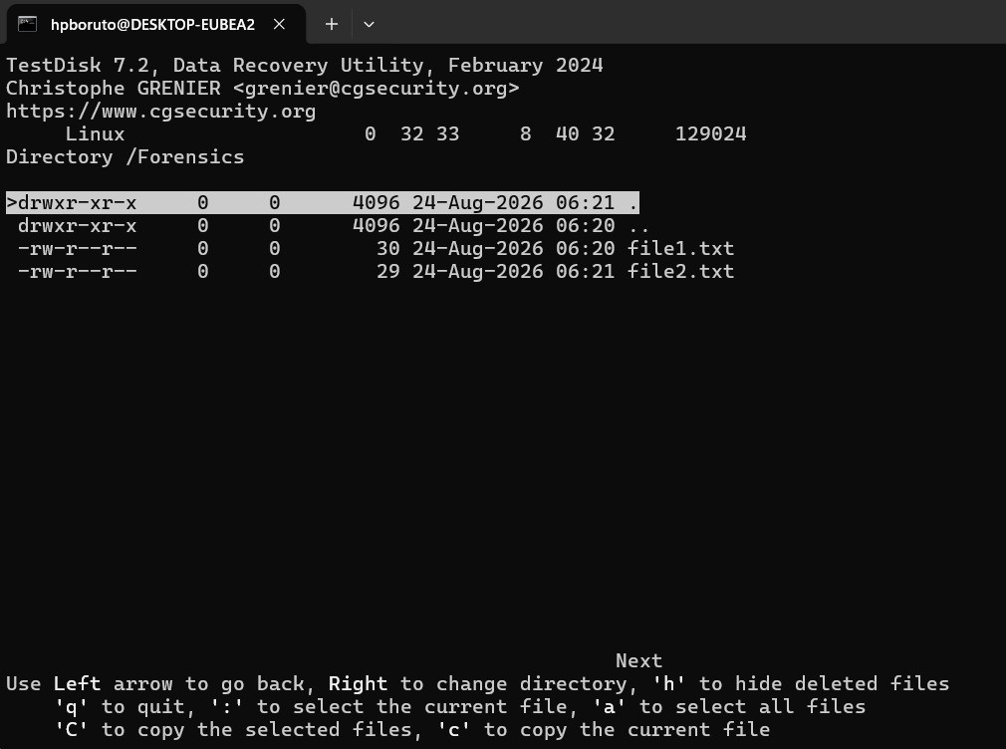

It works, your files are listed, you have found the correct partition!

- Use the left/right arrow to navigate into your folders and watch your files for more verification

Note: FAT directory listing is limited to 10 clusters - some files may not appear but it doesn't affect recovery.

- Press q for Quit to go back to the previous display.

- The available status are Primary, * bootable, Logical and Deleted.

Using the left/right arrow keys, change the status of the selected partition from Deleted to Logical. This way you will be able to recover this partition.

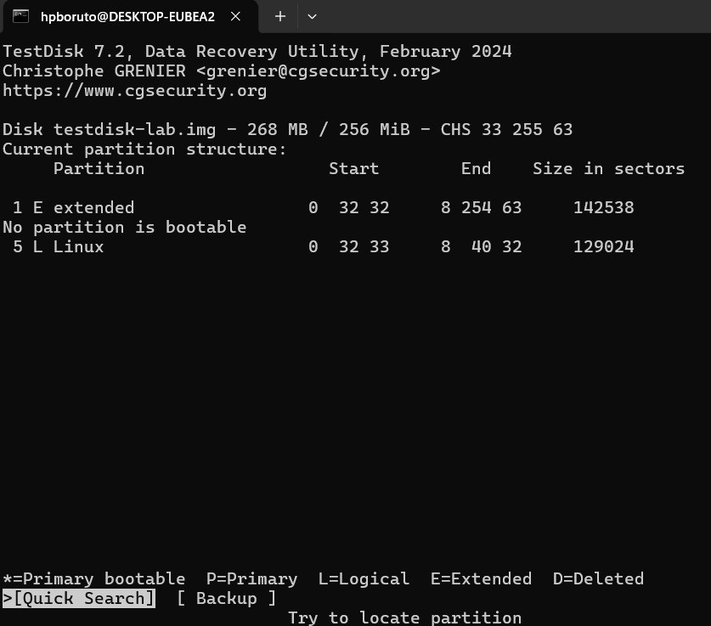

TestDisk displays You have to restart your Computer to access your data so press Enter a last time and reboot your computer.

Exp no :03 Date :
WIRESHARK FOR PASSWORD CAPTURING

Password Capturing
Wireshark can capture not only passwords but any type of information transmitted over the network: usernames, email
addresses, personal information, etc. As long as we can capture network traffic, Wireshark can sniff passing passwords.
In sniffing can include passwords for various protocols such as HTTP, FTP, Telnet, etc. the captured data can be used to
troubleshoot network problems, but can also be used maliciously to gain unauthorized access to sensitive information.
So, here we will see how we can capture the password using the Wireshark network capture analyzer. and see the outputs of the following steps.
Step 1: First of all, open your Wireshark tool in your window or in Linux virtual machine. and start capturing the network. suppose I am capturing my wireless fidelity.

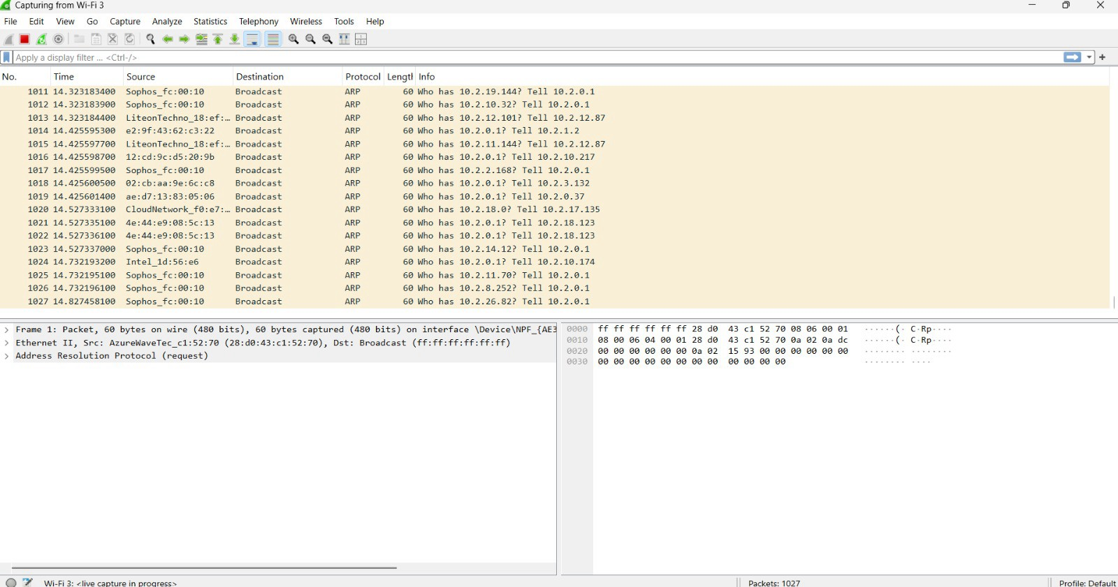

After starting the packet capturing we will go to the
website and login the credential on that website as you can see in the image

Step 3: Now after completing the login credential we will go and capture the password in Wireshark. for that we have to use some filter that helps to find the login credential through the packet capturing.

Step 4: Wireshark has captured some packets but we specifically looking for HTTP packets. so in the display filter bar we use some command to find all the captured HTTP packets. as you can http

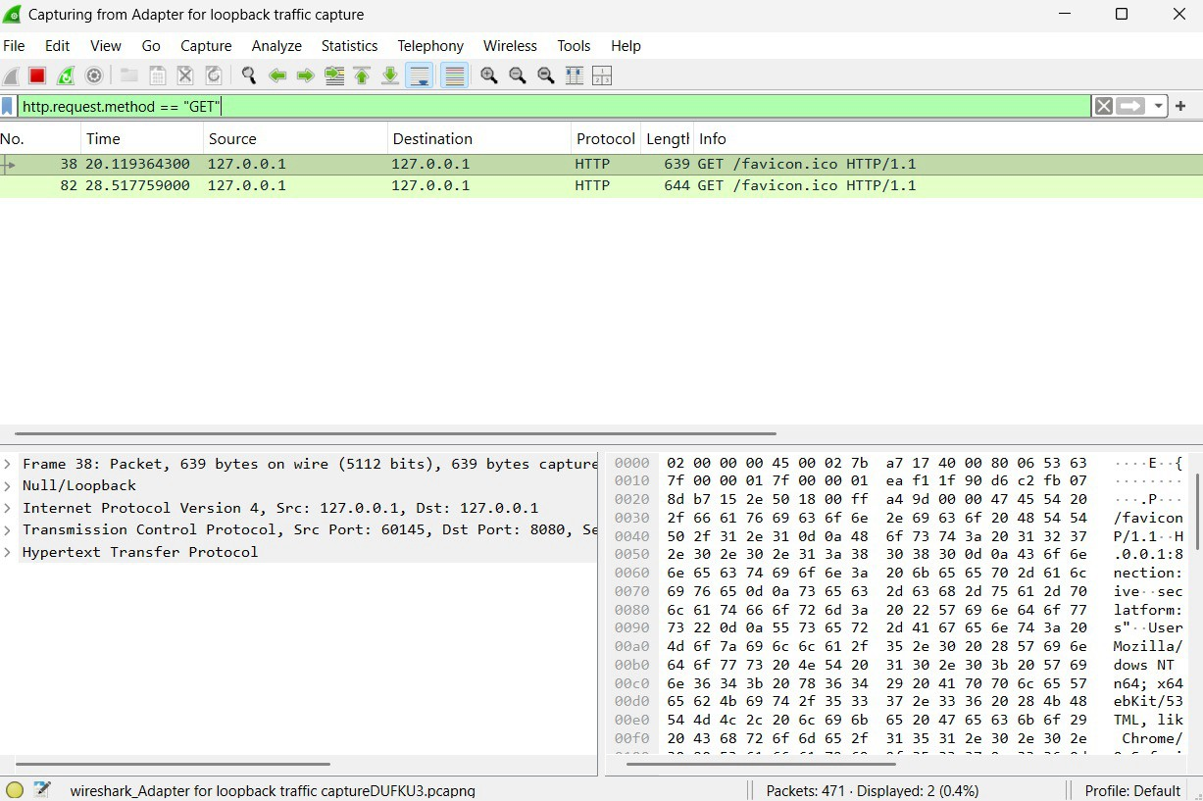

Step 5: So there are some HTTP packets are captured but we specifically looking for form data that the user submitted to the website. for that, we have a separate filter

As we know that there are main two methods used for submitting form data from web pages like login forms to the server. the
methods are-GET

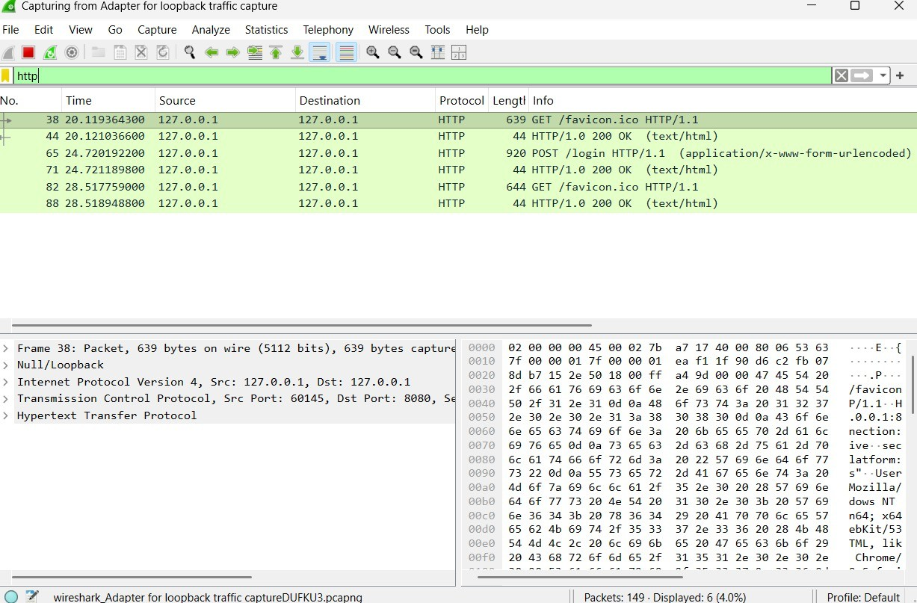

POST

Step 6: So firstly for knowing the credential we use the first method and apply the filter for the GET methods as you can see below.
http.request.method == "GET"
see in the below image the green bar where we apply the filter.

GET Method
As you can see in the image there are two packets where the login page was requested with a GET request as well, but

there is no form data submitted with a GET request.
Step 7: Now after checking the GET method if we didn’t find the form data, then we will try the POST method for that we will apply the filter on Wireshark as you can see.
http.request.method == "POST"

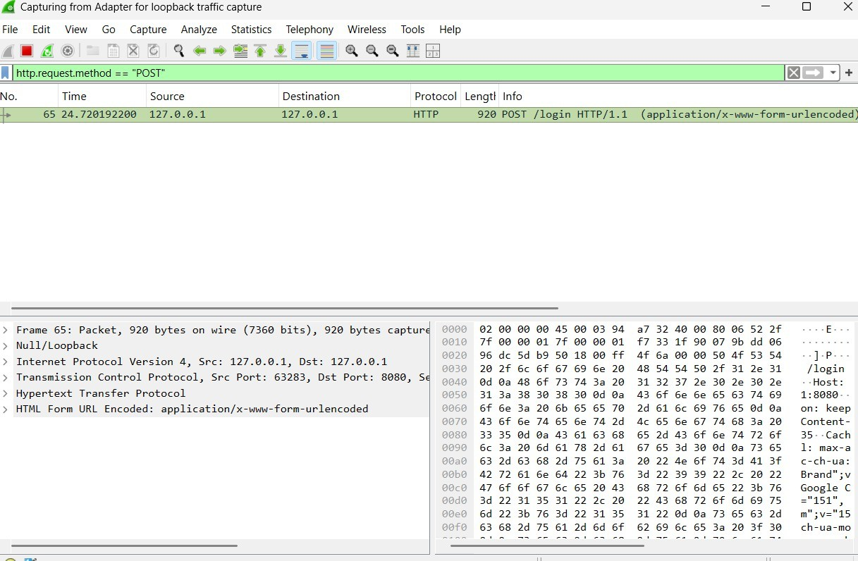

As you can see we have a packet with form data click on the packet with user info and the application URL encoded. and click on the down-

HTML form URL Encoded where the login credential is found. login credential as it is the same that we filed on the website in step 2.

Form item:"username"="raviprakash" Form item: "pass" = "Ravi123$"

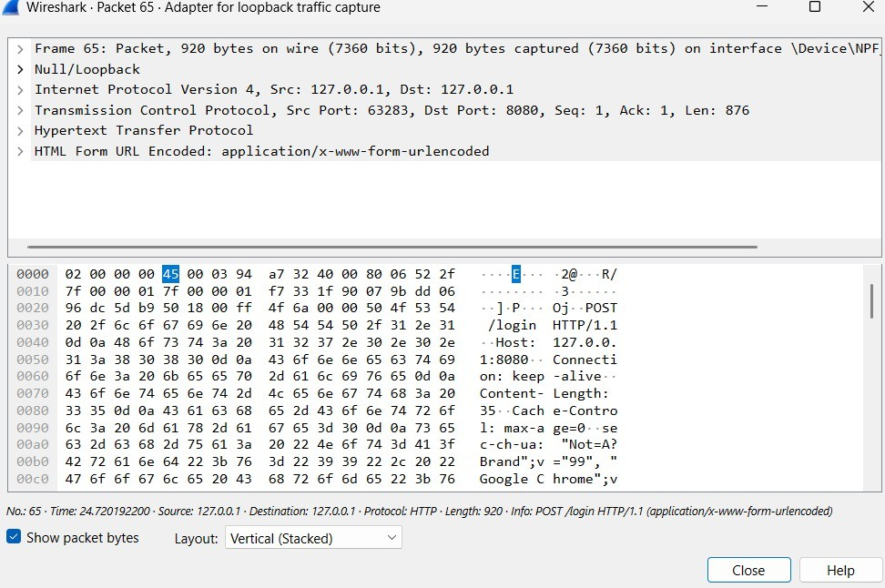

Exp no :04 Date :
Analyze email headers and detect email spoofing using MHA (Mail Header Analyzer)

Description:
Here's a step-by-step guide on how to execute and analyze an email header:

Access the Email Header
  - Gmail: Open the email, click the three dots (More) in the upper right corner, and select "Show original."
  - Outlook: Open the email, click on "File," then "Properties," and find the "Internet headers" box.
  - Yahoo: Open the email, click on the three dots (More), and select "View raw message."

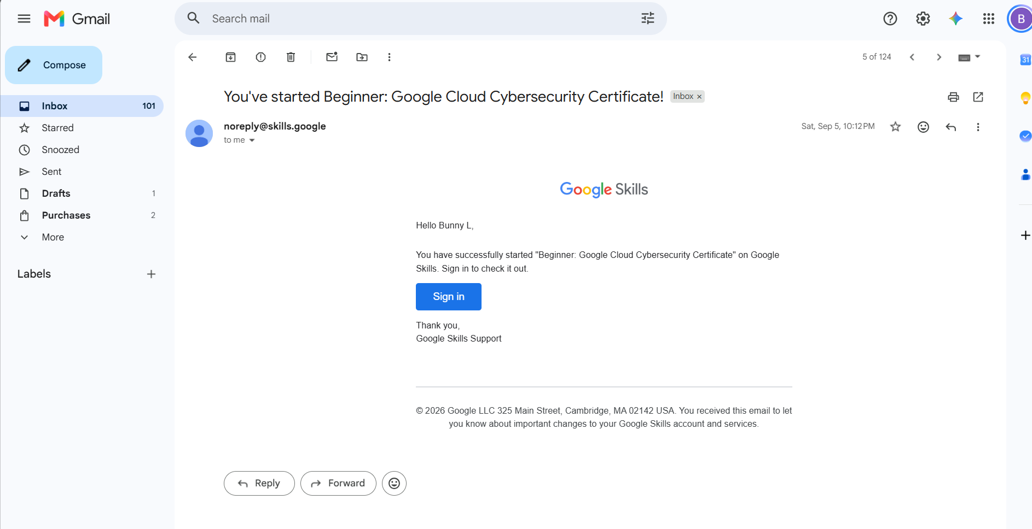

Copy the Email Header
  - Once you access the header, copy all the text that appears. This text contains various metadata fields about the email's journey from the sender to your inbox.

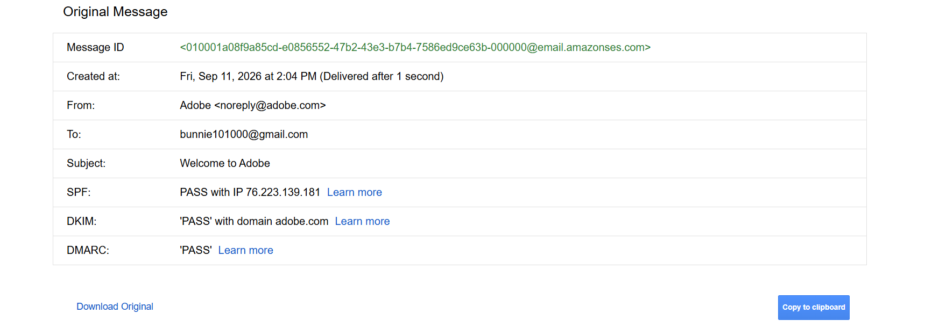

Identify Key Header Fields
  - From: The sender’s email address.
  - To: The recipient's email address.
  - Date: The date and time the email was sent.
  - Subject: The email's subject line.
  - Return-Path: The return address if the email bounces.
  - Received: A list of servers the email passed through on its way to the recipient. This is usually the most critical part of header analysis.
  - Message-ID: A unique identifier for the email.

SPF (Sender Policy Framework) / DKIM (DomainKeys Identified Mail):
Indicators of email authentication.

Analyze the ‘Received’ Fields
  - The Received fields show the path the email took from the sender to the recipient. These fields are listed in reverse order (from the last server to the first).
  - Each Received line will show:
    - The sending server's hostname/IP address.
    - The receiving server's hostname/IP address.
    - The date and time the email passed through.

- Check for IP Addresses and Hostnames
  - Use tools like WHOIS or online IP lookup services to identify the geographical location and ownership of the IP addresses found in the Received lines.
  - Check if any IP addresses are suspicious or if the hostname does not match the expected sending server.

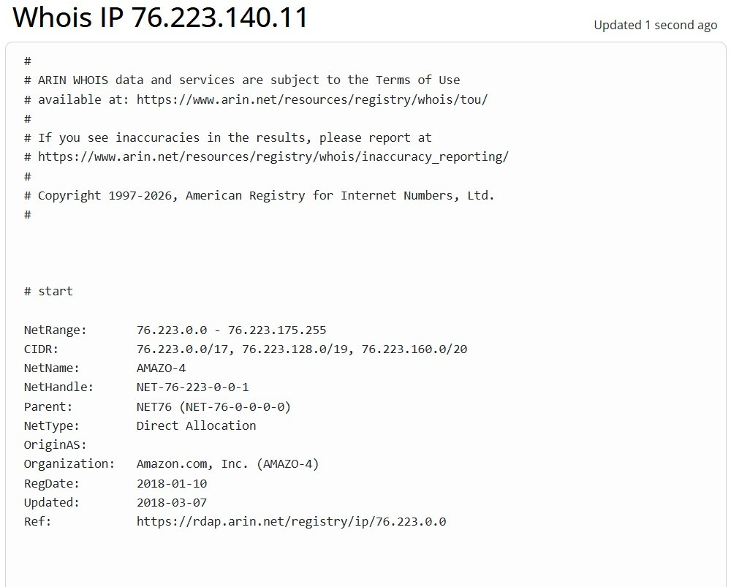

Examine the SPF, DKIM, and DMARC Results
  - SPF: Checks if the sender's IP is authorized to send emails for the domain.
    - Pass: Indicates the IP is authorized.
    - Fail: The IP is not authorized and could be a sign of spoofing.
  - DKIM: Verifies that the email content has not been altered in transit.
    - Pass: The email has not been tampered with.
    - Fail: The email content may have been altered.
  - DMARC: A policy that uses SPF and DKIM to authenticate the email.
    - Pass: Indicates alignment with SPF/DKIM policies.
    - Fail: Indicates possible spoofing or tampering.

Analyze the ‘Message-ID’
  - The Message-ID is unique to each email. It usually includes the domain of the sending server.
  - Check if the domain in the Message-ID matches the sender's domain. If not, it could be a sign of spoofing.

Look for Anomalies
  - Mismatch in Email Domains: Check if the From domain matches the domains in Return-Path, Message-ID, and other authentication results.
  - Strange IP Addresses: Be wary of IP addresses that do not match the known sending server or are from unexpected locations.
  - Suspicious Time Stamps: Check for significant time discrepancies in the Received lines, which could indicate delays or rerouting.

Use Online Tools
  - Use online email header analysis tools like MXToolbox or Google's G Suite Toolbox to automatically parse and analyze the email header.

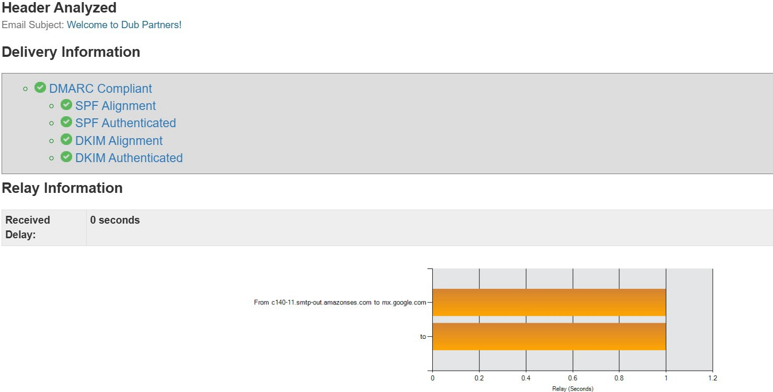

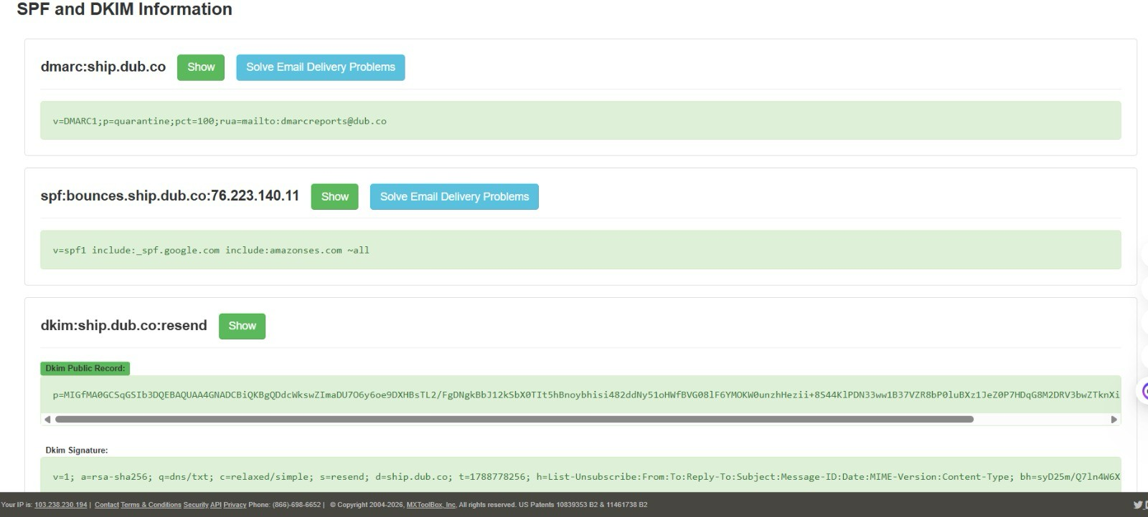

Document and Report Findings
  - Document all your findings, especially if you detect phishing or spoofing.
  - Report suspicious emails to your IT department or email provider for further investigation.

